**EE5415 Mobile Applications Design and Development**

**Tic Tac Toe Game Individual Project**

Name: ZHOU Ziyang

student ID: 55921210

Email: ziyanzhou5-c@my.cityu.edu.hk

Date: 2020/3/10

Here is the report of my “Tic Tac Toe” individual project.

I will introduce my project in modules respectively. The complete codes is attached at the end of report. If there is any problem in report or project source file, please contact me. Thank you!

**Catalog:**

1. “Tic Tac Toe” game implementation······················`·`···· 2

II. Support multiple language····························`··`··· 2

III. Support portrait and landscape display mode····················`·· 3

IV. Android and players take turns to start the game first, and game record···`·· 8

V. Create option memu with difficulty choose and game exit·············· 9

VI. Adding sound affects to the game···························· 11

VII. Adding history time record ······························· 12

VIII. Difficulty choose in game view····························· 13

IX. History record clear···································· 14

X. User preference······································· 15

Attachment (full codes of files)·································· 16

**I . “Tic Tac Toe” game implementation**

This part includes the basic functions of “Tic Tac Toe” game. The code is given so I omit this part here.

Here are screenshots of “Tic Tac Toe” game.

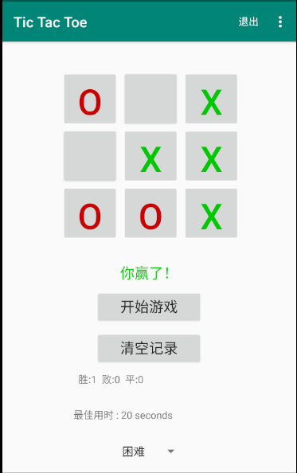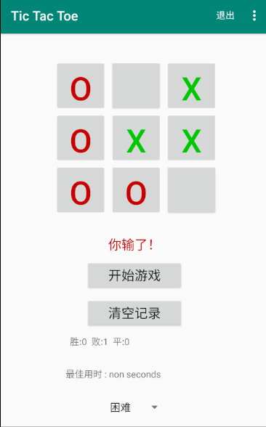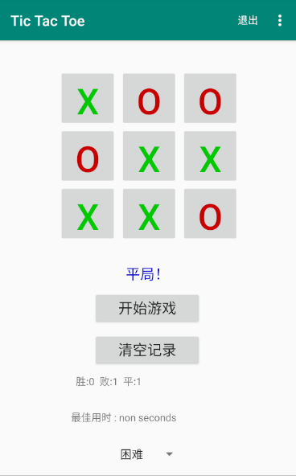

**II . support multiple language**

My project support English and Chinese.

Screenshots:

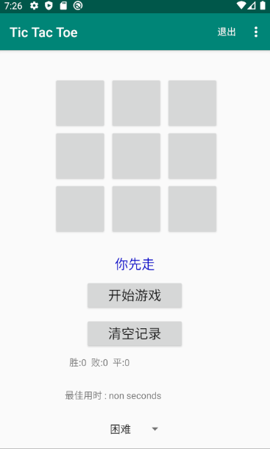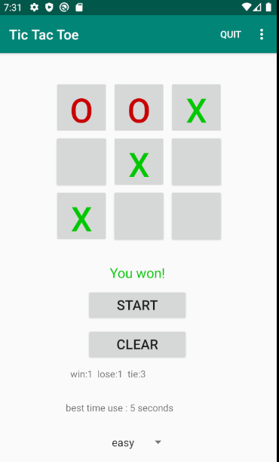

Code and Set up:

In res->values->strings, there are two strings.xml files to support English and Chinese.

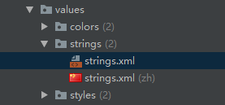

In strings.xml :

<resources>  
 <string name="app_name">Tic Tac Toe</string>  
 <string name="your_turn">It is your turn!</string>  
 <string name="android_turn">It is Android\'s turn!</string>  
 <string name="tie">It\'s a tie!</string>  
 <string name="won">You won!</string>  
 <string name="lose">You lose!</string>  
 <string name="begin">You go first.</string>  
 <string name="restart">Start</string>  
 <string name="a"> win:</string>  
 <string name="b"> lose:</string>  
 <string name="c"> tie:</string>  
 <string name="difficulty">difficulty</string>  
 <string name="clear">Clear</string>  
 <string name="quit">quit</string>  
 <string name="easy">easy</string>  
 <string name="hard">hard</string>  
 <string name="expert">expert</string>  
 <string name="bestTime">best time use :</string>  
 <string-array name="level">  
 <item>easy</item>  
 <item>hard</item>  
 <item>expert</item>  
 </string-array>  
</resources>

In strings.cml(ch)

<resources>  
 <string name="app_name">Tic Tac Toe</string>  
 <string name="your_turn">轮到你了</string>  
 <string name="android_turn">轮到安卓了</string>  
 <string name="tie">平局！</string>  
 <string name="won">你赢了！</string>  
 <string name="lose">你输了！</string>  
 <string name="begin">你先走</string>  
 <string name="restart">开始游戏</string>  
 <string name="a"> 胜:</string>  
 <string name="b"> 败:</string>  
 <string name="c"> 平:</string>  
 <string name="difficulty">难度</string>  
 <string name="clear">清空记录</string>  
 <string name="quit">退出</string>  
 <string name="easy">简单</string>  
 <string name="hard">困难</string>  
 <string name="expert">专家</string>  
 <string name="bestTime">最佳用时 :</string>  
 <string-array name="level">  
 <item>简单</item>  
 <item>困难</item>  
 <item>专家</item>  
 </string-array>  
</resources>

**III . support portrait and landscape display mode**

Screenshots:

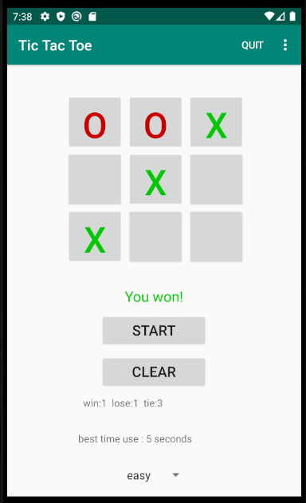 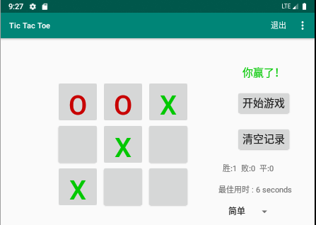

**Layout xml code:**

In portrait xml file:

<?xml version="1.0" encoding="utf-8"?>  
<LinearLayout xmlns:android="http://schemas.android.com/apk/res/android"  
 android:layout_width="fill_parent"  
 android:layout_height="fill_parent"  
 android:orientation="vertical"  
 android:padding="10dp" >  
 <TableLayout  
 android:layout_width="wrap_content"  
 android:layout_height="wrap_content"  
 android:layout_marginTop="30dp"  
 android:layout_gravity="center_horizontal" >  
 <TableRow  
 android:id="@+id/tableRow1"  
 android:layout_width="wrap_content"  
 android:layout_height="wrap_content" >  
 <Button  
 android:id="@+id/button0"  
 android:layout_width="80dp"  
 android:layout_height="80dp"  
 android:layout_marginLeft="5dp"  
 android:gravity="center"  
 android:text="1"  
 android:onClick="onButtonClicked"  
 android:textSize="50sp" />  
 <Button  
 android:id="@+id/button1"  
 android:layout_width="80dp"  
 android:layout_height="80dp"  
 android:layout_marginLeft="5dp"  
 android:text="2"  
 android:onClick="onButtonClicked"  
 android:textSize="50sp" />  
 <Button  
 android:id="@+id/button2"  
 android:layout_width="80dp"  
 android:layout_height="80dp"  
 android:layout_gravity="center_vertical"  
 android:layout_marginLeft="5dp"  
 android:text="3"  
 android:onClick="onButtonClicked"  
 android:textSize="50sp" />  
 </TableRow>  
 <TableRow  
 android:id="@+id/tableRow2"  
 android:layout_width="wrap_content"  
 android:layout_height="wrap_content" >  
 <Button  
 android:id="@+id/button3"  
 android:layout_width="80dp"  
 android:layout_height="80dp"  
 android:layout_marginLeft="5dp"  
 android:text="4"  
 android:onClick="onButtonClicked"  
 android:textSize="50sp" />  
 <Button  
 android:id="@+id/button4"  
 android:layout_width="80dp"  
 android:layout_height="80dp"  
 android:layout_marginLeft="5dp"  
 android:text="5"  
 android:onClick="onButtonClicked"  
 android:textSize="50sp" />  
 <Button  
 android:id="@+id/button5"  
 android:layout_width="80dp"  
 android:layout_height="80dp"  
 android:layout_marginLeft="5dp"  
 android:text="6"  
 android:onClick="onButtonClicked"  
 android:textSize="50sp" />  
 </TableRow>  
 <TableRow  
 android:id="@+id/tableRow3"  
 android:layout_width="wrap_content"  
 android:layout_height="wrap_content" >  
  
 <Button  
 android:id="@+id/button6"  
 android:layout_width="80dp"  
 android:layout_height="80dp"  
 android:layout_marginLeft="5dp"  
 android:onClick="onButtonClicked"  
 android:text="7"  
 android:textSize="50sp" />  
  
 <Button  
 android:id="@+id/button7"  
 android:layout_width="80dp"  
 android:layout_height="80dp"  
 android:layout_marginLeft="5dp"  
 android:text="8"  
 android:onClick="onButtonClicked"  
 android:textSize="50sp" />  
 <Button  
 android:id="@+id/button8"  
 android:layout_width="80dp"  
 android:layout_height="80dp"  
 android:layout_marginLeft="5dp"  
 android:text="9"  
 android:onClick="onButtonClicked"  
 android:textSize="50sp" />  
 </TableRow>  
 </TableLayout>  
  
 <LinearLayout  
 android:layout_width="match_parent"  
 android:layout_height="wrap_content"  
 android:layout_gravity="center_horizontal"  
 android:orientation="vertical"  
 android:padding="10dp">  
  
 <TextView  
 android:id="@+id/information"  
 android:layout_width="fill_parent"  
 android:layout_height="wrap_content"  
 android:layout_marginTop="20dp"  
 android:gravity="center_horizontal"  
 android:text="info"  
 android:textSize="20sp"></TextView>  
  
 <Button  
 android:id="@+id/button_restart"  
 android:layout_width="150dp"  
 android:layout_height="wrap_content"  
 android:layout_gravity="center_horizontal"  
 android:layout_marginTop="10dp"  
 android:onClick="newGame"  
 android:text="@string/restart"  
 android:textSize="20sp"></Button>  
 <Button  
 android:id="@+id/button_clear"  
 android:layout_width="150dp"  
 android:layout_height="wrap_content"  
 android:layout_gravity="center_horizontal"  
 android:layout_marginTop="10dp"  
 android:text="@string/clear"  
 android:textSize="20sp"  
 android:onClick="Clear"></Button>  
 <TextView  
 android:id="@+id/show_results"  
 android:layout_width="200dp"  
 android:layout_height="40dp"  
 android:layout_marginLeft="80dp"  
 android:layout_marginTop="10dp"  
 ></TextView>  
 <TextView  
 android:id="@+id/show_bestTime"  
 android:layout_width="200dp"  
 android:layout_height="40dp"  
 android:layout_marginLeft="80dp"  
 android:layout_marginTop="10dp"  
 ></TextView>  
 <Spinner  
 android:id="@+id/Level"  
 android:entries="@array/level"  
 android:tag="@string/difficulty"  
 android:layout_width="100dp"  
 android:layout_marginTop="10dp"  
 android:layout_marginLeft="140dp"  
 android:layout_height="wrap_content" />  
 </LinearLayout>  
</LinearLayout>

**In landscape xml file:**

<?xml version="1.0" encoding="utf-8"?>  
  
<RelativeLayout xmlns:android="http://schemas.android.com/apk/res/android"  
 android:layout_width="match_parent"  
 android:layout_height="match_parent" >  
  
 <TableLayout  
 android:layout_width="wrap_content"  
 android:layout_height="wrap_content"  
 android:layout_marginTop="80dp"  
 android:layout_marginLeft="100dp"  
 android:layout_gravity="center_horizontal" >  
 <TableRow  
 android:id="@+id/tableRow1"  
 android:layout_width="200dp"  
 android:layout_height="200dp" >  
 <Button  
 android:id="@+id/button0"  
 android:layout_width="80dp"  
 android:layout_height="80dp"  
 android:layout_marginLeft="5dp"  
 android:gravity="center"  
 android:text="1"  
 android:onClick="onButtonClicked"  
 android:textSize="50sp" />  
 <Button  
 android:id="@+id/button1"  
 android:layout_width="80dp"  
 android:layout_height="80dp"  
 android:layout_marginLeft="5dp"  
 android:text="2"  
 android:onClick="onButtonClicked"  
 android:textSize="50sp" />  
 <Button  
 android:id="@+id/button2"  
 android:layout_width="80dp"  
 android:layout_height="80dp"  
 android:layout_gravity="center_vertical"  
 android:layout_marginLeft="5dp"  
 android:text="3"  
 android:onClick="onButtonClicked"  
 android:textSize="50sp" />  
 </TableRow>  
 <TableRow  
 android:id="@+id/tableRow2"  
 android:layout_width="wrap_content"  
 android:layout_height="wrap_content" >  
 <Button  
 android:id="@+id/button3"  
 android:layout_width="80dp"  
 android:layout_height="80dp"  
 android:layout_marginLeft="5dp"  
 android:text="4"  
 android:onClick="onButtonClicked"  
 android:textSize="50sp" />  
 <Button  
 android:id="@+id/button4"  
 android:layout_width="80dp"  
 android:layout_height="80dp"  
 android:layout_marginLeft="5dp"  
 android:text="5"  
 android:onClick="onButtonClicked"  
 android:textSize="50sp" />  
 <Button  
 android:id="@+id/button5"  
 android:layout_width="80dp"  
 android:layout_height="80dp"  
 android:layout_marginLeft="5dp"  
 android:text="6"  
 android:onClick="onButtonClicked"  
 android:textSize="50sp" />  
 </TableRow>  
 <TableRow  
 android:id="@+id/tableRow3"  
 android:layout_width="wrap_content"  
 android:layout_height="wrap_content" >  
 <Button  
 android:id="@+id/button6"  
 android:layout_width="80dp"  
 android:layout_height="80dp"  
 android:layout_marginLeft="5dp"  
 android:text="7"  
 android:onClick="onButtonClicked"  
 android:textSize="50sp" />  
 <Button  
 android:id="@+id/button7"  
 android:layout_width="80dp"  
 android:layout_height="80dp"  
 android:layout_marginLeft="5dp"  
 android:text="8"  
 android:onClick="onButtonClicked"  
 android:textSize="50sp" />  
 <Button  
 android:id="@+id/button8"  
 android:layout_width="80dp"  
 android:layout_height="80dp"  
 android:layout_marginLeft="5dp"  
 android:text="9"  
 android:onClick="onButtonClicked"  
 android:textSize="50sp" />  
 </TableRow>  
 </TableLayout>  
 <LinearLayout  
 android:layout_width="200dp"  
 android:layout_height="340dp"  
 android:layout_gravity="center_horizontal"  
 android:layout_marginTop="20dp"  
 android:orientation="vertical"  
 android:layout_marginLeft="400dp"  
 android:padding="10dp" >  
 <TextView  
 android:id="@+id/information"  
 android:layout_width="fill_parent"  
 android:layout_height="wrap_content"  
 android:layout_marginTop="20dp"  
 android:gravity="center_horizontal"  
 android:text="info"  
 android:textSize="20sp" >  
 </TextView>  
 <Button  
 android:id="@+id/button_restart"  
 android:layout_width="wrap_content"  
 android:layout_height="wrap_content"  
 android:layout_gravity="center_horizontal"  
 android:layout_marginTop="20dp"  
 android:text="@string/restart"  
 android:textSize="20sp"  
 android:onClick="newGame" >  
 </Button>  
 <Button  
 android:id="@+id/button_clear"  
 android:layout_width="wrap_content"  
 android:layout_height="wrap_content"  
 android:layout_gravity="center_horizontal"  
 android:layout_marginTop="20dp"  
 android:text="@string/clear"  
 android:textSize="20sp"  
 android:onClick="Clear"></Button>  
  
 <TextView  
 android:id="@+id/show_results"  
 android:layout_width="wrap_content"  
 android:layout_height="wrap_content"  
 android:layout_marginTop="20dp"  
 ></TextView>  
 <TextView  
 android:id="@+id/show_bestTime"  
 android:layout_width="wrap_content"  
 android:layout_height="wrap_content"  
 android:layout_marginTop="20dp"  
 ></TextView>  
  
 <Spinner  
 android:id="@+id/Level"  
 android:entries="@array/level"  
 android:tag="@string/difficulty"  
 android:layout_width="100dp"  
 android:layout_marginTop="20dp"  
 android:layout_marginLeft="10dp"  
 android:layout_height="wrap_content" />  
 </LinearLayout>  
  
</RelativeLayout>

**IV . Android and players take turns to start the game first, and game record**

Screenshots:

Android begins firstly. Human player begins firstly.

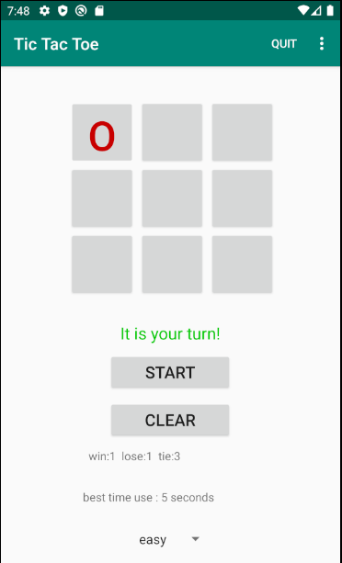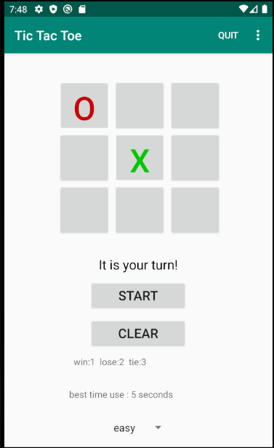

Game history record is behind



Code in MainActivity :

// game record  
private Button clearRecord;  
private int a,b,c,first;  
private String A,B,C;

In Oncreate() method: decide who first

//---Human goes first  
if (first==0)  
{  
 first=1;  
 mInfoTextView.setText(R.string.*begin*);  
}  
else // android goes first  
{  
 first=0;  
 int location=mGame.getComputerMove(ch);  
 mInfoTextView.setText(R.string.*your_turn*);  
 setMove(TicTacToeGame.*COMPUTER_PLAYER*, location);  
}

Outside the Oncreate method: show game history record

private void makeRecord()  
{  
 String x;  
 if (bestTime==-1)  
 {  
 x=getResources().getString(R.string.*bestTime*)+" non seconds";  
 }  
 else  
 {  
 x=getResources().getString(R.string.*bestTime*)+" "+bestTime+" seconds";  
 }  
 bestRecord.setText(x);  
  
 A=getResources().getString(R.string.*a*);  
 B=getResources().getString(R.string.*b*);  
 C=getResources().getString(R.string.*c*);  
  
 String S=" "+A+a+" "+B+b+" "+C+c;  
 showResults.setText(S);  
 savePreferences();  
}

**V . Create option memu with difficulty choose and game exit**

Screenshots:

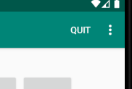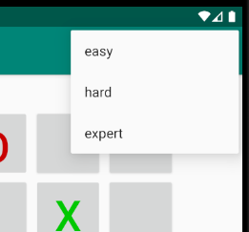

**Codes of memu:**

**Codes in res->memu->quit.xml**

<?xml version="1.0" encoding="utf-8"?>  
<menu xmlns:android="http://schemas.android.com/apk/res/android"  
 xmlns:app="http://schemas.android.com/apk/res-auto"  
 xmlns:tools="http://schemas.android.com/tools"  
 tools:context=".MainActivity">  
 <item  
 android:id="@+id/menu_easy"  
 android:title="@string/easy" />  
 <item  
 android:id="@+id/menu_hard"  
 android:title="@string/hard" />  
 <item  
 android:id="@+id/menu_expert"  
 android:title="@string/expert" />  
 <item  
 android:id="@+id/Quit"  
 android:title="@string/quit"  
 app:showAsAction="ifRoom" />  
</menu>

**Codes in MainActivity:**

**Outside of Oncreate() method:**

// difficulty choose and game exit  
@Override  
public boolean onCreateOptionsMenu(Menu menu) {  
 // Inflate the menu; this adds items to the aaction bar if it is present  
 getMenuInflater().inflate(R.menu.*quit*, menu);  
 return true; }  
@Override  
public boolean onOptionsItemSelected(MenuItem item) {  
 int id = item.getItemId();  
 switch (id) {  
 case R.id.*Quit*:  
 finish();  
 return true;  
 case R.id.*menu_easy*:  
 ch=1;  
 return true;  
 case R.id.*menu_hard*:  
 ch=2;  
 return true;  
 case R.id.*menu_expert*:  
 ch=3;  
 return true;  
 }  
 return false; }

**I modify the original getComputerMove() function in TicTacToeGame.java. Now it needs a parameter of difficulty level to get next movement. (1: easy 2: difficulty 3: expert)**

**AI with different difficulties in TicTacToeGame.java :**

public int getComputerMove(int level)  
{  
 // 1: easy 2: difficulty 3: expert  
 int move;  
 if(level==1)  
 {  
 for (int i = 0; i < *BOARD_SIZE*; i++) {  
 if (mBoard[i] != *HUMAN_PLAYER* && mBoard[i] != *COMPUTER_PLAYER*) {  
 mBoard[i] = *COMPUTER_PLAYER*;  
 return i;  
 }  
 }  
 }  
  
 // First see if there's a move O can make to win  
 for (int i = 0; i < *BOARD_SIZE*; i++) {  
 if (mBoard[i] != *HUMAN_PLAYER* && mBoard[i] != *COMPUTER_PLAYER*) {  
 char curr = mBoard[i];  
 mBoard[i] = *COMPUTER_PLAYER*;  
 if (checkForWinner() == 3) {  
 System.*out*.println("Computer is moving to " + (i + 1));  
 return i;  
 }  
 else  
 mBoard[i] = curr;  
 }  
 }  
 // See if there's a move O can make to block X from winning  
 for (int i = 0; i < *BOARD_SIZE*; i++) {  
 if (mBoard[i] != *HUMAN_PLAYER* && mBoard[i] != *COMPUTER_PLAYER*) {  
 char curr = mBoard[i]; // Save the current number  
 mBoard[i] = *HUMAN_PLAYER*;  
 if (checkForWinner() == 2) {  
 mBoard[i] = *COMPUTER_PLAYER*;  
 System.*out*.println("Computer is moving to " + (i + 1));  
 return i;  
 }  
 else  
 mBoard[i] = curr;  
 }  
 }  
 // Generate random move  
 if(level == 2)  
 {  
 do  
 {  
 move = mRand.nextInt(*BOARD_SIZE*);  
 } while (mBoard[move] == *HUMAN_PLAYER* || mBoard[move] == *COMPUTER_PLAYER*);  
 mBoard[move] = *COMPUTER_PLAYER*;  
 return move;  
 }  
 else  
 {  
 for (int i=0;i<9;i++)  
 {  
 if (mBoard[X[i]] != *HUMAN_PLAYER* && mBoard[X[i]] != *COMPUTER_PLAYER*) {  
 mBoard[X[i]]=*COMPUTER_PLAYER*;  
 return X[i];  
 }  
 }  
 return 0;  
 }  
}

**VI . adding sound affects to the game**

In my project, there are three kinds of sound to play when you win , lose and tie respectively.

Select and download three feasible music files and put them into **res->raw folder**. Then we can use them to play in app.

Screenshots: non

**Codes in MainActivity:**

// button music  
private SoundPool soundPool;  
private int soundIDwin,soundIDtie,soundIDlose;  
private MediaPlayer music;

private void PlayMusic(int MusicId) {  
 music = MediaPlayer.*create*(this, MusicId);  
 music.start();  
}  
  
@SuppressLint("NewApi")  
private void initSound() {  
 soundPool = new SoundPool.Builder().build();  
 soundIDwin = soundPool.load(this, R.raw.*win*, 1);  
 soundIDtie = soundPool.load(this, R.raw.*tie*, 1);  
 soundIDlose = soundPool.load(this, R.raw.*lose*, 1);  
}  
  
private void playSoundWin() {  
 soundPool.play(soundIDwin,1f,1f,0,0,1 );  
}  
private void playSoundTie() {  
 soundPool.play(soundIDtie,1f,1f,0,0,1 );  
}  
private void playSoundLose() {  
 soundPool.play(soundIDlose,1f,1f,0,0,1 );  
}

**VII . adding history time record**

**When player win, there will be a time he spend. If his time is less than the best record, the best record will be replaced and updated in TextView.**

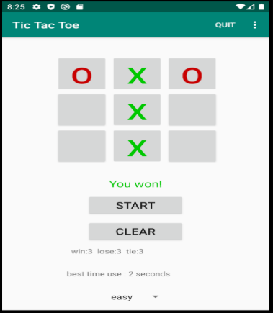 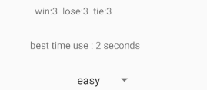

**Codes in MainActivity:**

// time record  
Calendar calendars;  
private int bestTime,startTime,endTime;  
private TextView bestRecord;

private int getTime() {  
 calendars = Calendar.*getInstance*();  
 calendars.setTimeZone(TimeZone.*getTimeZone*("GMT+8:00"));  
 int min = Integer.*parseInt*(String.*valueOf*(calendars.get(Calendar.*MINUTE*)));  
 int second = Integer.*parseInt*(String.*valueOf*(calendars.get(Calendar.*SECOND*)));  
 return min*60+second;  
}

private void updateTimeRecord()  
{  
 endTime=getTime();  
 if (startTime>endTime) endTime+=3600;  
 if (endTime-startTime<bestTime||bestTime==-1)  
 {  
 bestTime=endTime-startTime;  
 makeRecord();  
 }  
}  
private void makeRecord()  
{  
 String x;  
 if (bestTime==-1)  
 {  
 x=getResources().getString(R.string.*bestTime*)+" non seconds";  
 }  
 else  
 {  
 x=getResources().getString(R.string.*bestTime*)+" "+bestTime+" seconds";  
 }  
 bestRecord.setText(x);  
  
 A=getResources().getString(R.string.*a*);  
 B=getResources().getString(R.string.*b*);  
 C=getResources().getString(R.string.*c*);  
  
 String S=" "+A+a+" "+B+b+" "+C+c;  
 showResults.setText(S);  
 savePreferences();  
}

**In newGame() method:**

startTime=getTime();

**VIII . difficulty choose in game view**

**I use Spinner in game view to choose game difficulty.**

**Screenshots:**

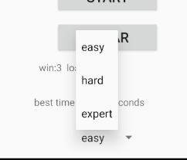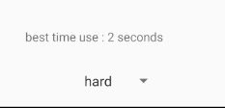

**Codes in layout:**

<Spinner  
 android:id="@+id/Level"  
 android:entries="@array/level"  
 android:tag="@string/difficulty"  
 android:layout_width="100dp"  
 android:layout_marginTop="10dp"  
 android:layout_marginLeft="140dp"  
 android:layout_height="wrap_content" />

**Codes in string.xml**

<string-array name="level">  
 <item>easy</item>  
 <item>hard</item>  
 <item>expert</item>  
</string-array>

**Codes in Mainactivity.java**

**In Oncreate() method:**

choose = (Spinner) findViewById(R.id.*Level*);  
choose.setOnItemSelectedListener(new AdapterView.OnItemSelectedListener() {  
 @Override  
 public void onItemSelected(AdapterView<?> parent, View view, int position, long id) {  
 //获取到Spinner下列选项值  
 String val = choose.getItemAtPosition(position).toString();  
 //Toast.makeText(MainActivity.this,val,Toast.LENGTH_LONG).show();  
  
 if (val.equals("简单")||val.equals("easy")) ch=1;  
 else if (val.equals("困难")||val.equals("hard")) ch=2;  
 else if (val.equals("专家")||val.equals("expert")) ch=3;  
 else  
 {  
 Toast.*makeText*(MainActivity.this,"wrong!",Toast.*LENGTH_LONG*).show();  
 }  
 }  
  
 @Override  
 public void onNothingSelected(AdapterView<?> parent) {  
 ch=1;  
 }  
});

**IX . history record clear**

**I set a button to clear all history records, including win-lose-tie data and best spending time record.**

**Screenshots:**

**Before click “CLEAR” after click “CLEAR”**

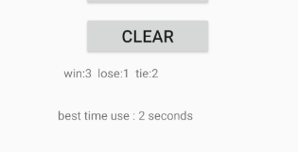 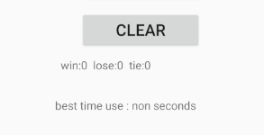

**Codes in MainActivity.java**

// game record  
private Button clearRecord;  
private int a,b,c,first;  
private String A,B,C;

// clear record  
public void Clear(View v)  
{  
 a=0;  
 b=0;  
 c=0;  
 bestTime=-1;  
 makeRecord();  
}

**Codes in Layout:**

<Button  
 android:id="@+id/button_clear"  
 android:layout_width="wrap_content"  
 android:layout_height="wrap_content"  
 android:layout_gravity="center_horizontal"  
 android:layout_marginTop="20dp"  
 android:text="@string/clear"  
 android:textSize="20sp"  
 android:onClick="Clear"></Button>

**X . user preference**

**I set the user preference to show last data record includes win-lose-tie record and best-time record.**

**Screenshot :**

**Before I close the game close the game and open it again**

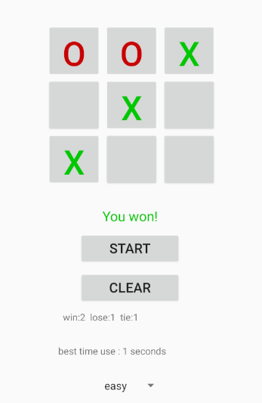 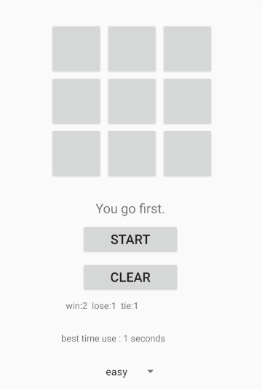

**Codes in MainActivity.java**

public void savePreferences() {  
 SharedPreferences pref = getSharedPreferences("TicTac", *MODE_PRIVATE*);  
 String _a=String.*valueOf*(a);  
 String _b=String.*valueOf*(b);  
 String _c=String.*valueOf*(c);  
 String _t=String.*valueOf*(bestTime);  
 pref.edit().putString("a", _a).apply();  
 pref.edit().putString("b", _b).apply();  
 pref.edit().putString("c", _c).apply();  
 pref.edit().putString("t", _t).apply();  
}  
public void loadPreferences() {  
 SharedPreferences pref = getSharedPreferences("TicTac", *MODE_PRIVATE*);  
 a=Integer.*parseInt*(pref.getString("a", "0"));  
 b=Integer.*parseInt*(pref.getString("b", "0"));  
 c=Integer.*parseInt*(pref.getString("c", "0"));  
 bestTime=Integer.*parseInt*(pref.getString("t", "-1"));  
}  
  
@Override  
protected void onStart() {  
 super.onStart();  
 loadPreferences(); }

**Codes in Oncreate() method:**

loadPreferences();

**Codes in makeRecord()**

savePreferences();

**Attachment**

**Complete codes in files**

**MainActivity.java**

package com.example.tictactoe;  
  
import androidx.appcompat.app.AppCompatActivity;  
  
import android.annotation.SuppressLint;  
import android.content.SharedPreferences;  
import android.graphics.Color;  
import android.media.MediaPlayer;  
import android.media.SoundPool;  
import android.os.Bundle;  
import android.view.Menu;  
import android.view.MenuItem;  
import android.view.View;  
import android.widget.AdapterView;  
import android.widget.Button;  
import android.widget.Spinner;  
import android.widget.TextView;  
import android.widget.Toast;  
  
import java.util.Calendar;  
import java.util.TimeZone;  
  
  
public class MainActivity extends AppCompatActivity {  
 // Represents the internal state of the game  
  
 private TicTacToeGame mGame;  
 private Button mBoardButtons[];  
 // Various text displayed  
 private TextView mInfoTextView;  
 private TextView showResults;  
  
 // game record  
 private Button clearRecord;  
 private int a,b,c,first;  
 private String A,B,C;  
  
 // Restart Button  
 private Button startButton;  
 Boolean mGameOver;  
  
 // difficulty choose  
 private Spinner choose;  
 private int ch;  
  
 // button music  
 private SoundPool soundPool;  
 private int soundIDwin,soundIDtie,soundIDlose;  
 private MediaPlayer music;  
  
 // time record  
 Calendar calendars;  
 private int bestTime,startTime,endTime;  
 private TextView bestRecord;  
  
 @Override  
 protected void onCreate(Bundle savedInstanceState) {  
 super.onCreate(savedInstanceState);  
 setContentView(R.layout.*activity_main*);  
  
  
 initSound();  
  
 startTime=getTime();  
 loadPreferences();  
 first=0;  
 bestRecord=(TextView)findViewById(R.id.*show_bestTime*);  
 showResults=(TextView) findViewById(R.id.*show_results*);  
  
 makeRecord();  
  
 choose = (Spinner) findViewById(R.id.*Level*);  
 choose.setOnItemSelectedListener(new AdapterView.OnItemSelectedListener() {  
 @Override  
 public void onItemSelected(AdapterView<?> parent, View view, int position, long id) {  
 //获取到Spinner下列选项值  
 String val = choose.getItemAtPosition(position).toString();  
 //Toast.makeText(MainActivity.this,val,Toast.LENGTH_LONG).show();  
  
 if (val.equals("简单")||val.equals("easy")) ch=1;  
 else if (val.equals("困难")||val.equals("hard")) ch=2;  
 else if (val.equals("专家")||val.equals("expert")) ch=3;  
 else  
 {  
 Toast.*makeText*(MainActivity.this,"wrong!",Toast.*LENGTH_LONG*).show();  
 }  
 }  
  
 @Override  
 public void onNothingSelected(AdapterView<?> parent) {  
 ch=1;  
 }  
 });  
  
  
 // Buttons making up the board  
  
 mGame = new TicTacToeGame();  
  
 mBoardButtons = new Button[mGame.*BOARD_SIZE*];  
 mBoardButtons[0] = (Button) findViewById(R.id.*button0*);  
 mBoardButtons[1] = (Button) findViewById(R.id.*button1*);  
 mBoardButtons[2] = (Button) findViewById(R.id.*button2*);  
 mBoardButtons[3] = (Button) findViewById(R.id.*button3*);  
 mBoardButtons[4] = (Button) findViewById(R.id.*button4*);  
 mBoardButtons[5] = (Button) findViewById(R.id.*button5*);  
 mBoardButtons[6] = (Button) findViewById(R.id.*button6*);  
 mBoardButtons[7] = (Button) findViewById(R.id.*button7*);  
 mBoardButtons[8] = (Button) findViewById(R.id.*button8*);  
 mInfoTextView = (TextView) findViewById(R.id.*information*);  
 mGame = new TicTacToeGame();  
  
 startNewGame();  
 }  
  
 //--- Set up the game board.  
 private void startNewGame() {  
 mGameOver = false;  
 mGame.clearBoard();  
 //---Reset all buttons  
 for (int i = 0; i < mBoardButtons.length; i++) {  
 mBoardButtons[i].setText("");  
 mBoardButtons[i].setEnabled(true);  
 mBoardButtons[i].setOnClickListener(new ButtonClickListener(i));  
 }  
 //---Human goes first  
 if (first==0)  
 {  
 first=1;  
 mInfoTextView.setText(R.string.*begin*);  
 }  
 else // android goes first  
 {  
 first=0;  
 int location=mGame.getComputerMove(ch);  
 mInfoTextView.setText(R.string.*your_turn*);  
 setMove(TicTacToeGame.*COMPUTER_PLAYER*, location);  
 }  
  
 }  
  
 private class ButtonClickListener implements View.OnClickListener {  
 int location;  
  
 public ButtonClickListener(int location) {  
 this.location = location;  
 }  
  
 @Override  
 public void onClick(View v) {  
 if (mGameOver == false) {  
 if (mBoardButtons[location].isEnabled()) {  
 setMove(TicTacToeGame.*HUMAN_PLAYER*, location);  
 //--- If no winner yet, let the computer make a move  
 int winner = mGame.checkForWinner();  
 if (winner == 0) {  
 mInfoTextView.setText(R.string.*android_turn*);  
 int move = mGame.getComputerMove(ch);  
 setMove(TicTacToeGame.*COMPUTER_PLAYER*, move);  
 winner = mGame.checkForWinner();  
 }  
 if (winner == 0) {  
 mInfoTextView.setTextColor(Color.*rgb*(0, 0, 0));  
 mInfoTextView.setText(R.string.*your_turn*);  
 } else if (winner == 1) {  
 playSoundTie();  
 c+=1;  
 mInfoTextView.setTextColor(Color.*rgb*(0, 0, 200));  
 mInfoTextView.setText(R.string.*tie*);  
 makeRecord();  
 mGameOver = true;  
 } else if (winner == 2) {  
 updateTimeRecord();  
 playSoundWin();  
 a+=1;  
 mInfoTextView.setTextColor(Color.*rgb*(0, 200, 0));  
 mInfoTextView.setText(R.string.*won*);  
 makeRecord();  
 mGameOver = true;  
 } else {  
 playSoundLose();  
 b+=1;  
 mInfoTextView.setTextColor(Color.*rgb*(200, 0, 0));  
 mInfoTextView.setText(R.string.*lose*);  
 makeRecord();  
 mGameOver = true;  
 }  
 }  
 }  
 }  
 }  
  
 private void setMove(char player, int location) {  
 mGame.setMove(player, location);  
 mBoardButtons[location].setEnabled(false);  
 mBoardButtons[location].setText(String.*valueOf*(player));  
 if (player == TicTacToeGame.*HUMAN_PLAYER*)  
 mBoardButtons[location].setTextColor(Color.*rgb*(0, 200, 0));  
 else  
 mBoardButtons[location].setTextColor(Color.*rgb*(200, 0, 0));  
 }  
 //--- OnClickListener for Restart a New Game Button  
 public void newGame(View v) {  
 startTime=getTime();  
 startNewGame();  
 }  
  
 // clear record  
 public void Clear(View v)  
 {  
 a=0;  
 b=0;  
 c=0;  
 bestTime=-1;  
 makeRecord();  
 }  
  
 // difficulty choose and game exit  
 @Override  
 public boolean onCreateOptionsMenu(Menu menu) {  
 // Inflate the menu; this adds items to the aaction bar if it is present  
 getMenuInflater().inflate(R.menu.*quit*, menu);  
 return true; }  
 @Override  
 public boolean onOptionsItemSelected(MenuItem item) {  
 int id = item.getItemId();  
 switch (id) {  
 case R.id.*Quit*:  
 finish();  
 return true;  
 case R.id.*menu_easy*:  
 ch=1;  
 return true;  
 case R.id.*menu_hard*:  
 ch=2;  
 return true;  
 case R.id.*menu_expert*:  
 ch=3;  
 return true;  
 }  
 return false; }  
  
  
 private void PlayMusic(int MusicId) {  
 music = MediaPlayer.*create*(this, MusicId);  
 music.start();  
 }  
  
 @SuppressLint("NewApi")  
 private void initSound() {  
 soundPool = new SoundPool.Builder().build();  
 soundIDwin = soundPool.load(this, R.raw.*win*, 1);  
 soundIDtie = soundPool.load(this, R.raw.*tie*, 1);  
 soundIDlose = soundPool.load(this, R.raw.*lose*, 1);  
 }  
  
 private void playSoundWin() {  
 soundPool.play(soundIDwin,1f,1f,0,0,1 );  
 }  
 private void playSoundTie() {  
 soundPool.play(soundIDtie,1f,1f,0,0,1 );  
 }  
 private void playSoundLose() {  
 soundPool.play(soundIDlose,1f,1f,0,0,1 );  
 }  
  
  
 private int getTime() {  
 calendars = Calendar.*getInstance*();  
 calendars.setTimeZone(TimeZone.*getTimeZone*("GMT+8:00"));  
 int min = Integer.*parseInt*(String.*valueOf*(calendars.get(Calendar.*MINUTE*)));  
 int second = Integer.*parseInt*(String.*valueOf*(calendars.get(Calendar.*SECOND*)));  
 return min*60+second;  
 }  
  
 private void updateTimeRecord()  
 {  
 endTime=getTime();  
 if (startTime>endTime) endTime+=3600;  
 if (endTime-startTime<bestTime||bestTime==-1)  
 {  
 bestTime=endTime-startTime;  
 makeRecord();  
 }  
 }  
  
 private void makeRecord()  
 {  
 String x;  
 if (bestTime==-1)  
 {  
 x=getResources().getString(R.string.*bestTime*)+" non seconds";  
 }  
 else  
 {  
 x=getResources().getString(R.string.*bestTime*)+" "+bestTime+" seconds";  
 }  
 bestRecord.setText(x);  
  
 A=getResources().getString(R.string.*a*);  
 B=getResources().getString(R.string.*b*);  
 C=getResources().getString(R.string.*c*);  
  
 String S=" "+A+a+" "+B+b+" "+C+c;  
 showResults.setText(S);  
 savePreferences();  
 }  
  
 public void savePreferences() {  
 SharedPreferences pref = getSharedPreferences("TicTac", *MODE_PRIVATE*);  
 String _a=String.*valueOf*(a);  
 String _b=String.*valueOf*(b);  
 String _c=String.*valueOf*(c);  
 String _t=String.*valueOf*(bestTime);  
 pref.edit().putString("a", _a).apply();  
 pref.edit().putString("b", _b).apply();  
 pref.edit().putString("c", _c).apply();  
 pref.edit().putString("t", _t).apply();  
 }  
 public void loadPreferences() {  
 SharedPreferences pref = getSharedPreferences("TicTac", *MODE_PRIVATE*);  
 a=Integer.*parseInt*(pref.getString("a", "0"));  
 b=Integer.*parseInt*(pref.getString("b", "0"));  
 c=Integer.*parseInt*(pref.getString("c", "0"));  
 bestTime=Integer.*parseInt*(pref.getString("t", "-1"));  
 }  
  
 @Override  
 protected void onStart() {  
 super.onStart();  
 loadPreferences(); }  
}

**TicTacToeGame.java**

package com.example.tictactoe;/* TicTacToeConsole.java  
 * By Frank McCown (Harding University)  
 *  
 * This is a tic-tac-toe game that runs in the console window. The human  
 * is X and the computer is O.  
 */  
  
import android.annotation.SuppressLint;  
import android.media.MediaPlayer;  
import android.media.SoundPool;  
import android.widget.Toast;  
  
import java.util.InputMismatchException;  
import java.util.Random;  
import java.util.Scanner;  
  
public class TicTacToeGame {  
  
 // Characters used to represent the human, computer, and open spots  
 public static final char *HUMAN_PLAYER* = 'X';  
 public static final char *COMPUTER_PLAYER* = 'O';  
 public static final char *OPEN_SPOT* = ' ';  
 public static final int *BOARD_SIZE* = 9;  
 private char mBoard[] = { '1', '2', '3', '4', '5', '6', '7', '8', '9' };  
 private int X[]={4,0,2,6,8,1,3,5,7};  
 private Random mRand;  
  
 public TicTacToeGame() {  
 // Seed the random number generator  
 mRand = new Random();  
 char turn = *HUMAN_PLAYER*; // Human starts first  
 int win = 0; // Set to 1, 2, or 3 when game is over  
 }  
  
 public void clearBoard() {  
 for (int i = 0; i < *BOARD_SIZE*; i++) {  
 mBoard[i] = *OPEN_SPOT*;  
 } }  
 */** Set the given player at the given location on the game board * */* public void setMove(char player, int location) {  
 mBoard[location] = player;  
 }  
  
 // Check for a winner. Return  
 // 0 if no winner or tie yet  
 // 1 if it's a tie  
 // 2 if X won  
 // 3 if O won  
 public int checkForWinner() {  
  
 // Check horizontal wins  
 for (int i = 0; i <= 6; i += 3) {  
 if (mBoard[i] == *HUMAN_PLAYER* &&  
 mBoard[i+1] == *HUMAN_PLAYER* &&  
 mBoard[i+2]== *HUMAN_PLAYER*)  
 return 2;  
 if (mBoard[i] == *COMPUTER_PLAYER* &&  
 mBoard[i+1]== *COMPUTER_PLAYER* &&  
 mBoard[i+2] == *COMPUTER_PLAYER*)  
 return 3;  
 }  
  
 // Check vertical wins  
 for (int i = 0; i <= 2; i++) {  
 if (mBoard[i] == *HUMAN_PLAYER* &&  
 mBoard[i+3] == *HUMAN_PLAYER* &&  
 mBoard[i+6]== *HUMAN_PLAYER*)  
 return 2;  
 if (mBoard[i] == *COMPUTER_PLAYER* &&  
 mBoard[i+3] == *COMPUTER_PLAYER* &&  
 mBoard[i+6]== *COMPUTER_PLAYER*)  
 return 3;  
 }  
  
 // Check for diagonal wins  
 if ((mBoard[0] == *HUMAN_PLAYER* &&  
 mBoard[4] == *HUMAN_PLAYER* &&  
 mBoard[8] == *HUMAN_PLAYER*) ||  
 (mBoard[2] == *HUMAN_PLAYER* &&  
 mBoard[4] == *HUMAN_PLAYER* &&  
 mBoard[6] == *HUMAN_PLAYER*))  
 return 2;  
 if ((mBoard[0] == *COMPUTER_PLAYER* &&  
 mBoard[4] == *COMPUTER_PLAYER* &&  
 mBoard[8] == *COMPUTER_PLAYER*) ||  
 (mBoard[2] == *COMPUTER_PLAYER* &&  
 mBoard[4] == *COMPUTER_PLAYER* &&  
 mBoard[6] == *COMPUTER_PLAYER*))  
 return 3;  
  
 // Check for tie  
 for (int i = 0; i < *BOARD_SIZE*; i++) {  
 // If we find a number, then no one has won yet  
 if (mBoard[i] != *HUMAN_PLAYER* && mBoard[i] != *COMPUTER_PLAYER*)  
 return 0;  
 }  
  
 // If we make it through the previous loop, all places are taken, so it's a tie  
 return 1;  
 }  
  
 public int getComputerMove(int level)  
 {  
  
 int move;  
 if(level==1)  
 {  
 for (int i = 0; i < *BOARD_SIZE*; i++) {  
 if (mBoard[i] != *HUMAN_PLAYER* && mBoard[i] != *COMPUTER_PLAYER*) {  
 mBoard[i] = *COMPUTER_PLAYER*;  
 return i;  
 }  
 }  
 }  
  
 // First see if there's a move O can make to win  
 for (int i = 0; i < *BOARD_SIZE*; i++) {  
 if (mBoard[i] != *HUMAN_PLAYER* && mBoard[i] != *COMPUTER_PLAYER*) {  
 char curr = mBoard[i];  
 mBoard[i] = *COMPUTER_PLAYER*;  
 if (checkForWinner() == 3) {  
 System.*out*.println("Computer is moving to " + (i + 1));  
 return i;  
 }  
 else  
 mBoard[i] = curr;  
 }  
 }  
 // See if there's a move O can make to block X from winning  
 for (int i = 0; i < *BOARD_SIZE*; i++) {  
 if (mBoard[i] != *HUMAN_PLAYER* && mBoard[i] != *COMPUTER_PLAYER*) {  
 char curr = mBoard[i]; // Save the current number  
 mBoard[i] = *HUMAN_PLAYER*;  
 if (checkForWinner() == 2) {  
 mBoard[i] = *COMPUTER_PLAYER*;  
 System.*out*.println("Computer is moving to " + (i + 1));  
 return i;  
 }  
 else  
 mBoard[i] = curr;  
 }  
 }  
 // Generate random move  
 if(level == 2)  
 {  
 do  
 {  
 move = mRand.nextInt(*BOARD_SIZE*);  
 } while (mBoard[move] == *HUMAN_PLAYER* || mBoard[move] == *COMPUTER_PLAYER*);  
 mBoard[move] = *COMPUTER_PLAYER*;  
 return move;  
 }  
 else  
 {  
 for (int i=0;i<9;i++)  
 {  
 if (mBoard[X[i]] != *HUMAN_PLAYER* && mBoard[X[i]] != *COMPUTER_PLAYER*) {  
 mBoard[X[i]]=*COMPUTER_PLAYER*;  
 return X[i];  
 }  
 }  
 return 0;  
 }  
 }  
  
  
}

**Activity_main.xml (here I omit the layout in landscape display mode)**

<?xml version="1.0" encoding="utf-8"?>  
<LinearLayout xmlns:android="http://schemas.android.com/apk/res/android"  
 android:layout_width="fill_parent"  
 android:layout_height="fill_parent"  
 android:orientation="vertical"  
 android:padding="10dp" >  
 <TableLayout  
 android:layout_width="wrap_content"  
 android:layout_height="wrap_content"  
 android:layout_gravity="center_horizontal" >  
 <TableRow  
 android:id="@+id/tableRow1"  
 android:layout_width="wrap_content"  
 android:layout_height="wrap_content" >  
 <Button  
 android:id="@+id/button0"  
 android:layout_width="80dp"  
 android:layout_height="80dp"  
 android:layout_marginLeft="5dp"  
 android:gravity="center"  
 android:text="1"  
 android:onClick="onButtonClicked"  
 android:textSize="50sp" />  
 <Button  
 android:id="@+id/button1"  
 android:layout_width="80dp"  
 android:layout_height="80dp"  
 android:layout_marginLeft="5dp"  
 android:text="2"  
 android:onClick="onButtonClicked"  
 android:textSize="50sp" />  
 <Button  
 android:id="@+id/button2"  
 android:layout_width="80dp"  
 android:layout_height="80dp"  
 android:layout_gravity="center_vertical"  
 android:layout_marginLeft="5dp"  
 android:text="3"  
 android:onClick="onButtonClicked"  
 android:textSize="50sp" />  
 </TableRow>  
 <TableRow  
 android:id="@+id/tableRow2"  
 android:layout_width="wrap_content"  
 android:layout_height="wrap_content" >  
 <Button  
 android:id="@+id/button3"  
 android:layout_width="80dp"  
 android:layout_height="80dp"  
 android:layout_marginLeft="5dp"  
 android:text="4"  
 android:onClick="onButtonClicked"  
 android:textSize="50sp" />  
 <Button  
 android:id="@+id/button4"  
 android:layout_width="80dp"  
 android:layout_height="80dp"  
 android:layout_marginLeft="5dp"  
 android:text="5"  
 android:onClick="onButtonClicked"  
 android:textSize="50sp" />  
 <Button  
 android:id="@+id/button5"  
 android:layout_width="80dp"  
 android:layout_height="80dp"  
 android:layout_marginLeft="5dp"  
 android:text="6"  
 android:onClick="onButtonClicked"  
 android:textSize="50sp" />  
 </TableRow>  
 <TableRow  
 android:id="@+id/tableRow3"  
 android:layout_width="wrap_content"  
 android:layout_height="wrap_content" >  
 <Button  
 android:id="@+id/button6"  
 android:layout_width="80dp"  
 android:layout_height="80dp"  
 android:layout_marginLeft="5dp"  
 android:text="7"  
 android:onClick="onButtonClicked"  
 android:textSize="50sp" />  
 <Button  
 android:id="@+id/button7"  
 android:layout_width="80dp"  
 android:layout_height="80dp"  
 android:layout_marginLeft="5dp"  
 android:text="8"  
 android:onClick="onButtonClicked"  
 android:textSize="50sp" />  
 <Button  
 android:id="@+id/button8"  
 android:layout_width="80dp"  
 android:layout_height="80dp"  
 android:layout_marginLeft="5dp"  
 android:text="9"  
 android:onClick="onButtonClicked"  
 android:textSize="50sp" />  
 </TableRow>  
 </TableLayout>  
 <LinearLayout  
 android:layout_width="match_parent"  
 android:layout_height="wrap_content"  
 android:layout_gravity="center_horizontal"  
 android:orientation="vertical"  
 android:padding="10dp" >  
 <TextView  
 android:id="@+id/information"  
 android:layout_width="fill_parent"  
 android:layout_height="wrap_content"  
 android:layout_marginTop="20dp"  
 android:gravity="center_horizontal"  
 android:text="info"  
 android:textSize="20sp" >  
 </TextView>  
 <Button  
 android:id="@+id/button_restart"  
 android:layout_width="wrap_content"  
 android:layout_height="wrap_content"  
 android:layout_gravity="center_horizontal"  
 android:layout_marginTop="20dp"  
 android:text="Start a New Game"  
 android:textSize="20sp"  
 android:onClick="newGame" >  
 </Button>  
 <Button  
 android:id="@+id/button_clear"  
 android:layout_width="wrap_content"  
 android:layout_height="wrap_content"  
 android:layout_gravity="center_horizontal"  
 android:layout_marginTop="20dp"  
 android:text="clear data"  
 android:textSize="20sp"  
 android:onClick="Clear">  
 </Button>  
 <TextView  
 android:id="@+id/show_results"  
 android:layout_width="200dp"  
 android:layout_height="40dp"  
 android:layout_marginLeft="80dp"  
 android:layout_marginTop="20dp"  
 ></TextView>  
 <TextView  
 android:id="@+id/show_bestTime"  
 android:layout_width="200dp"  
 android:layout_height="40dp"  
 android:layout_marginLeft="80dp"  
 android:layout_marginTop="20dp"  
 ></TextView>  
 <Spinner  
 android:id="@+id/Level"  
 android:entries="@array/level"  
 android:tag="@string/difficulty"  
 android:layout_width="100dp"  
 android:layout_marginTop="40dp"  
 android:layout_marginLeft="150dp"  
 android:layout_height="wrap_content" />  
  
 </LinearLayout>  
</LinearLayout>

**Res->Memu->quit.xml (memu layout)**

<?xml version="1.0" encoding="utf-8"?>  
<menu xmlns:android="http://schemas.android.com/apk/res/android"  
 xmlns:app="http://schemas.android.com/apk/res-auto"  
 xmlns:tools="http://schemas.android.com/tools"  
 tools:context=".MainActivity">  
 <item  
 android:id="@+id/menu_easy"  
 android:title="@string/easy" />  
 <item  
 android:id="@+id/menu_hard"  
 android:title="@string/hard" />  
 <item  
 android:id="@+id/menu_expert"  
 android:title="@string/expert" />  
 <item  
 android:id="@+id/Quit"  
 android:title="@string/quit"  
 app:showAsAction="ifRoom" />  
</menu>

**Res->values->strings->strings.xml (English supporting Edition)**

<resources>  
 <string name="app_name">Tic Tac Toe</string>  
 <string name="your_turn">It is your turn!</string>  
 <string name="android_turn">It is Android\'s turn!</string>  
 <string name="tie">It\'s a tie!</string>  
 <string name="won">You won!</string>  
 <string name="lose">You lose!</string>  
 <string name="begin">You go first.</string>  
 <string name="restart">Start</string>  
 <string name="a"> win:</string>  
 <string name="b"> lose:</string>  
 <string name="c"> tie:</string>  
 <string name="difficulty">difficulty</string>  
 <string name="clear">Clear</string>  
 <string name="quit">quit</string>  
 <string name="easy">easy</string>  
 <string name="hard">hard</string>  
 <string name="expert">expert</string>  
 <string name="bestTime">best time use :</string>  
 <string-array name="level">  
 <item>easy</item>  
 <item>hard</item>  
 <item>expert</item>  
 </string-array>  
</resources>

**Res->values->strings->strings.xml (Chinese supporting Edition)**

<resources>  
 <string name="app_name">Tic Tac Toe</string>  
 <string name="your_turn">轮到你了</string>  
 <string name="android_turn">轮到安卓了</string>  
 <string name="tie">平局！</string>  
 <string name="won">你赢了！</string>  
 <string name="lose">你输了！</string>  
 <string name="begin">你先走</string>  
 <string name="restart">开始游戏</string>  
 <string name="a"> 胜:</string>  
 <string name="b"> 败:</string>  
 <string name="c"> 平:</string>  
 <string name="difficulty">难度</string>  
 <string name="clear">清空记录</string>  
 <string name="quit">退出</string>  
 <string name="easy">简单</string>  
 <string name="hard">困难</string>  
 <string name="expert">专家</string>  
 <string name="bestTime">最佳用时 :</string>  
 <string-array name="level">  
 <item>简单</item>  
 <item>困难</item>  
 <item>专家</item>  
 </string-array>  
</resources>